U9 Find the Gap

Coaching soccer for U9 age group starts to get more technical now as the players get older and begin to understand the gamer a little bit more. It is however important to keep the sessions and drills fun and exciting. This drill is called find the gap and can is ideally suited for 5/6 players although more or less can be involved.
Preparation
Take a look at the diagram below. You will need some cones to mark out a long rectangle in the middle and a single soccer ball amongst the group.

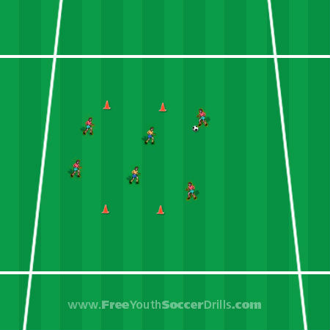

Explanation
Your players should hopefully have a good understanding now of passing the soccer ball and keeping the ball away from opposition defenders. The aim of this game is simple, the outside players (in red) must try and pass the ball to the other side without the defending players (in yellow) getting control of the ball. The defending players must stay inside the coned area.
Coaching soccer at this level should be all about learning one or two new things per session while re-capping on lots of things previously done in other sessions.
This game is all about creating angles to allow a successful pass to the other-side. Therefore, to help your players with this game recommend them passing the ball to the other player on their side to see if they have a gap in which to pass. They could keep doing this until a gap appears.
It might be that the players have to pass first time without controlling the ball so not to allow the defenders to close the gap.
This drill is also very good practice for the defending players. They should try not to allow a gap to appear through to the other side and work together to close the ball down.

Progression
This game can sometimes be tricky with two defenders, if this is the case, remove one of the defenders and see if more successful passes are made.
A really good progression to this drill is to make the defending rectangle in to a larger square and have a red player at each four sides of the square. You could give 1 point for a sideways pass to left or right and 2 points for passing to the other-side parallel with them.

Coaching Points
-> Ensure that the correct passing technique is used. I.e. side of the foot and not the toe
-> Make sure the defenders start to understand where to position themselves and move around to block any pass
-> The outside players don't have to stay still, they can move about to ensure better passing angles

